Appendix C: IEEE 830 Template
Software Requirements Specification
for
Smart Thermostat Controller

Version 1.0.4
Prepared by Mikołaj Sołtysiński
TUL Lodz University of Technology IFE/WEEIA
22.05.2026

Table of Contents
Appendix C: IEEE 830 Template 1
1. Introduction 4
1.1. Purpose 4
1.2. Document Conventions 4
1.3. Intended Audience and Reading Suggestions 4
1.4. Product Scope 4
1.5. References 4
2. Overall Description 5
2.1. Product Perspective 5
2.2. Product Features 5
2.3. User Classes and Characteristics 5
2.4. Operating Environment 5
2.5. Design and Implementation Constraints 6
2.6. User Documentation 6
2.7. Assumptions and Dependencies 6
3. System Features 7
3.0 Use Case Diagram 7
3.1. HVAC Regulation Logic 7
3.2 Target Temperature Override 7
4. External Interface Requirements 8
4.1. User Interfaces Overview 8
4.2. Hardware Interfaces 8
4.3. Software Interfaces 9
5. System Features/Modules 10
5.1. HVAC Regulation Logic 10
5.1.1 Description and Priority 10
5.1.2 Stimulus/Response Sequences 10
5.1.3 Functional Requirements 10
5.2 Target Temperature Override 11
5.2.1 Description and Priority 11
5.2.2 Stimulus/Response Sequences 11
5.2.3 Functional Requirements 11
6. Nonfunctional Requirements 11
6.1. Performance 11
6.2. Security 11
6.3. Usability 11

Revision History
Name | Date | Reason for Changes | Version
Mikołaj Sołtysiński | 22.05.2026 | Initial Version | 1.0.0
Mikołaj Sołtysiński | 28.05.2026 | Added Use Case and Class Diagrams  Added sections 2.4, 2.5, 2.5, 2.7 | 1.0.1
Mikołaj Sołtysiński | 01.06.2026 | Added section 4 and 5  Added State Diagram | 1.0.2
Mikołaj Sołtysiński | 06.06.2026 | Added section 3, 6 | 1.0.3
Mikołaj Sołtysiński | 11.06.2026 | Refactor, clarified technical details | 1.0.4

1. Introduction

1.1. Purpose
This document specifies the engineering and software requirements for Version 1.0.4 of the Smart Thermostat Controller. This specification defines the system’s core functional behavior and boundaries. The scope of this initial release covers four primary operational areas: physical temperature sensor data collection, weekly target temperature scheduling profiles, hysteresis-based HVAC relay enforcement, and user credential authentication.

1.2. Document Conventions
This specification complies with the structure defined by the IEEE Std 830-1998 standard. Every distinct requirement statement is assigned its own priority and operates as an independent, verifiable unit. To guarantee traceability throughout the development lifecycle, we enforce a strict tagging convention using unique identifiers (e.g., REQ-1.1, NF-1.1).

1.3. Intended Audience and Reading Suggestions
This document is meant to be used by many different team members across the project lifecycle. We recommend navigating the document based on your project role:
Project Managers and Stakeholders: Read Section 1 (Introduction) and Section 2 (Overall Description) to evaluate the product scope and operational constraints.
Software Developers and Architects: Focus directly on Section 4 (External Interface Requirements), Section 5 (System Features), and Section 6 (Nonfunctional Requirements) to guide code implementation.
Quality Assurance (QA) and Testing Teams: Use Section 5 and Section 6 as the primary criteria to construct automated and manual test verification procedures.

1.4. Product Scope
The Smart Thermostat Controller is a web-connected embedded software application built to manage indoor climates within residential and commercial structures. Traditional manual thermostats often allow wide temperature swings, which leads to excessive energy consumption and physical discomfort. This system resolves that issue by automating climate adjustment through tight boundaries and automated schedule routines.
The application tracks live ambient metrics, executes user-programmed weekly heating/cooling schedules, protects physical hardware equipment by enforcing short-cycling delays, and executes automated relay state changes based on physical room telemetry. Automating these workflows maintains stable indoor temperatures and lowers HVAC system runtime to meet energy conservation targets.

1.5. References
- Juwaied, A. (PhD). “Software Engineering LAB 1: REQUIREMENTS ANALYSIS”. Lodz University of Technology - IFE.
- IEEE Computer Society. “IEEE Recommended Practice for Software Requirements Specifications” (IEEE Std 830-1998).

2. Overall Description

2.1. Product Perspective
The Smart Thermostat Controller is a standalone software product designed to govern a distributed configuration of heating and cooling units throughout a building. Unlike legacy mechanical thermostats that depend on physical dials and constant user intervention, this system uses digital logic to maintain target conditions.
Users interact with the system via a web application optimized for desktop and mobile web browsers, facilitating remote adjustments. The application backend coordinates physical sensor inputs, schedules, relay triggers, and administrative configuration parameters.

2.2. Product Features
The system provides the following distinct capabilities:
- Displaying real-time ambient temperature metrics.
- Displaying real-time relative humidity metrics.
- Displaying the active 7-day heating and cooling schedule.
- Changing the target temperature setpoint.
- Adjusting the operational mode to HEAT, COOL, AUTO, or ECO.
- Displaying active schedule overrides.
- Scheduling a temporary temperature override.
- Canceling a temporary temperature override.
- Recording historical HVAC equipment runtimes.
- Logging energy consumption metrics.

2.3. User Classes and Characteristics
Residents represent the primary user group of the system. They will use the system to view ambient temperature, set schedules, and make target temperature overrides.
Characteristics:
- basic technical knowledge
- daily system usage throughout the year
- access through mobile devices or laptops
Administrators/Technicians represent the secondary user group of the system. They will use the system to configure system safety bounds, view runtime diagnostics, and perform system calibration.
Characteristics:
- high technical expertise and system familiarity
- periodic system usage during maintenance and setup
- access via dedicated management panels or local terminals

2.4. Operating Environment
The environment requirements specify where the application executes:
- ENV-1.1: The user dashboard client shall execute within standard web browsers on both desktop resolutions and mobile display screens.
- ENV-1.2: The controller firmware application shall run natively on Raspberry Pi or ESP32 embedded hardware systems.
- ENV-1.3: The backend application services shall execute on a local network server or cloud infrastructure platform.

2.5. Design and Implementation Constraints
Operational boundaries limit the engineering choices available to the developers:
- CON-1.1: The system shall require user authentication before granting access to configuration dashboards.
- CON-1.2: The climate regulation logic shall enforce a minimum delay of 300 seconds (5 minutes) between successive HVAC relay state toggles to protect equipment compressors from short-cycling.
- CON-1.3: The application shall automatically turn off all active HVAC relays if the measured ambient temperature drops below 5°C.
- CON-1.4: The application shall automatically turn off all active HVAC relays if the measured ambient temperature exceeds 35°C.

2.6. User Documentation
The documentation suite will be delivered in digital format via a web sub-page to support end users:
- DOC-1.1: The developer shall provide an online user guide detailing weekly schedule programming workflows.
- DOC-1.2: The developer shall provide an online user guide detailing temporary override steps.
- DOC-1.3: The developer shall provide an installer manual outlining low-level physical GPIO wiring connections.
- DOC-1.4: The developer shall provide an installer manual outlining sensor calibration procedures.
- DOC-1.5: The web dashboard shall host an embedded help module that is accessible from any system screen.

2.7. Assumptions and Dependencies
The technical requirements rely on the following external baseline factors:
- ASM-1.1: The local physical temperature and occupancy sensors are assumed to be operational and factory-calibrated.
- ASM-1.2: The building infrastructure is assumed to provide a continuous, local Wi-Fi connection.
- DEP-1.1: The system depends on external HVAC hardware that responds to standard 24V AC control signals over R, W, Y, and G terminal connections.
- DEP-1.2: Remote browser interaction depends on the user’s host hardware maintaining active internet connectivity.

3. System Features

3.0 Use Case Diagram
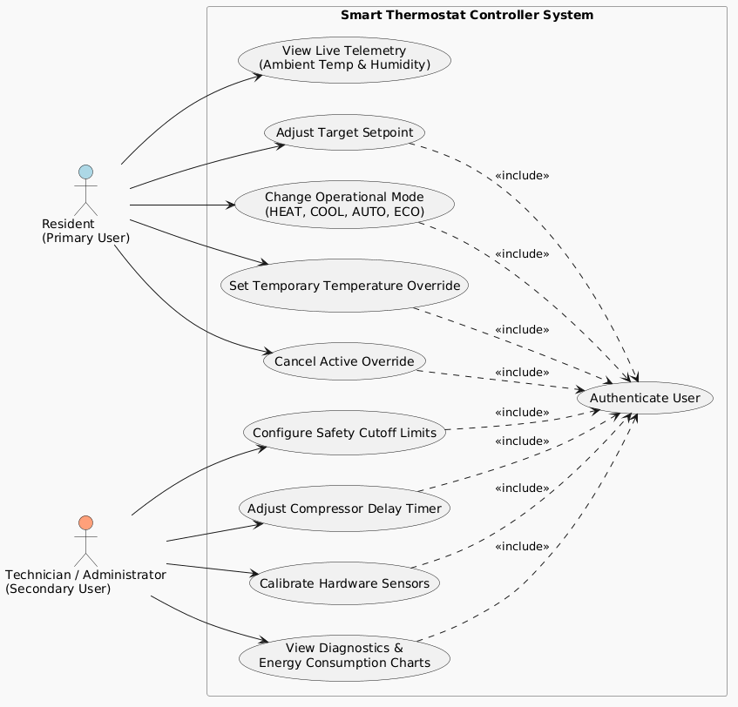

3.1. HVAC Regulation Logic
The software continuously evaluates ambient room data against user settings and a fixed hysteresis value. It safely switches the heating or cooling relays while protecting physical components from rapid cycling.

3.2 Target Temperature Override
The application accepts authenticated user inputs to temporarily substitute the active schedule profile with a manual temperature setpoint for a defined period.

4. External Interface Requirements

4.1. User Interfaces Overview
The web application provides a Graphical User Interface (GUI) to handle system interactions.
- UI-1.1: The GUI shall include a Login Screen for entering user credentials.
- UI-1.2: The GUI shall include a Thermostat Dashboard that displays the current ambient temperature.
- UI-1.3: The GUI shall include a Thermostat Dashboard that displays the current ambient relative humidity.
- UI-1.4: The GUI shall include a Thermostat Dashboard that displays the active HVAC operational state (HEATING, COOLING, or IDLE).
- UI-1.5: The GUI shall include a Thermostat Dashboard that provides a touch-compatible adjustment dial for updating target temperatures.
- UI-1.6: The GUI shall include a Schedule Editor that renders a 7-day calendar layout containing time blocks.
- UI-1.7: The GUI shall include a Safety Configuration Panel that allows technicians to define high/low cutoff limits.
- UI-1.8: The GUI shall include a Safety Configuration Panel that allows technicians to adjust compressor short-cycling delays.
- UI-1.9: The GUI shall include a Diagnostics Dashboard that displays equipment runtime trend charts.
- UI-1.10: The GUI shall include a Diagnostics Dashboard that displays calculated energy consumption statistics.
- UI-1.11: The interface shall display a visual confirmation dialogue within 2.0 seconds after a user saves a schedule change.
- UI-1.12: The interface shall display a high-visibility warning alert within 1.0 second if an override input falls below 5°C.
- UI-1.13: The interface shall display a high-visibility warning alert within 1.0 second if an override input exceeds 35°C.
- UI-1.14: The layout configuration of the GUI shall adjust dynamically to fit viewport widths ranging between 320 pixels and 3840 pixels.

4.2. Hardware Interfaces
The application manages interactions with physical hardware components through micro-controller terminals:
- HWI-1.1: The system shall read temperature telemetry data from a DHT22/DS18B20 digital sensor via an assigned GPIO input pin.
- HWI-1.2: The system shall sample data from the digital temperature sensor at a periodic interval of 10 seconds.
- HWI-1.3: The system shall read relative humidity data from a DHT22 sensor via an assigned GPIO input pin.
- HWI-1.4: The firmware shall output a digital signal (3.3V high or 0V low) to a heating relay GPIO terminal pin to regulate 24V AC lines.
- HWI-1.5: The firmware shall output a digital signal (3.3V high or 0V low) to a cooling relay GPIO terminal pin to regulate 24V AC lines.
- HWI-1.6: The firmware shall output a digital signal (3.3V high or 0V low) to a system fan relay GPIO terminal pin to regulate 24V AC lines.

4.3. Software Interfaces
To provide a clear overview of the system's internal structure and data organization, the following Class Diagram was created:
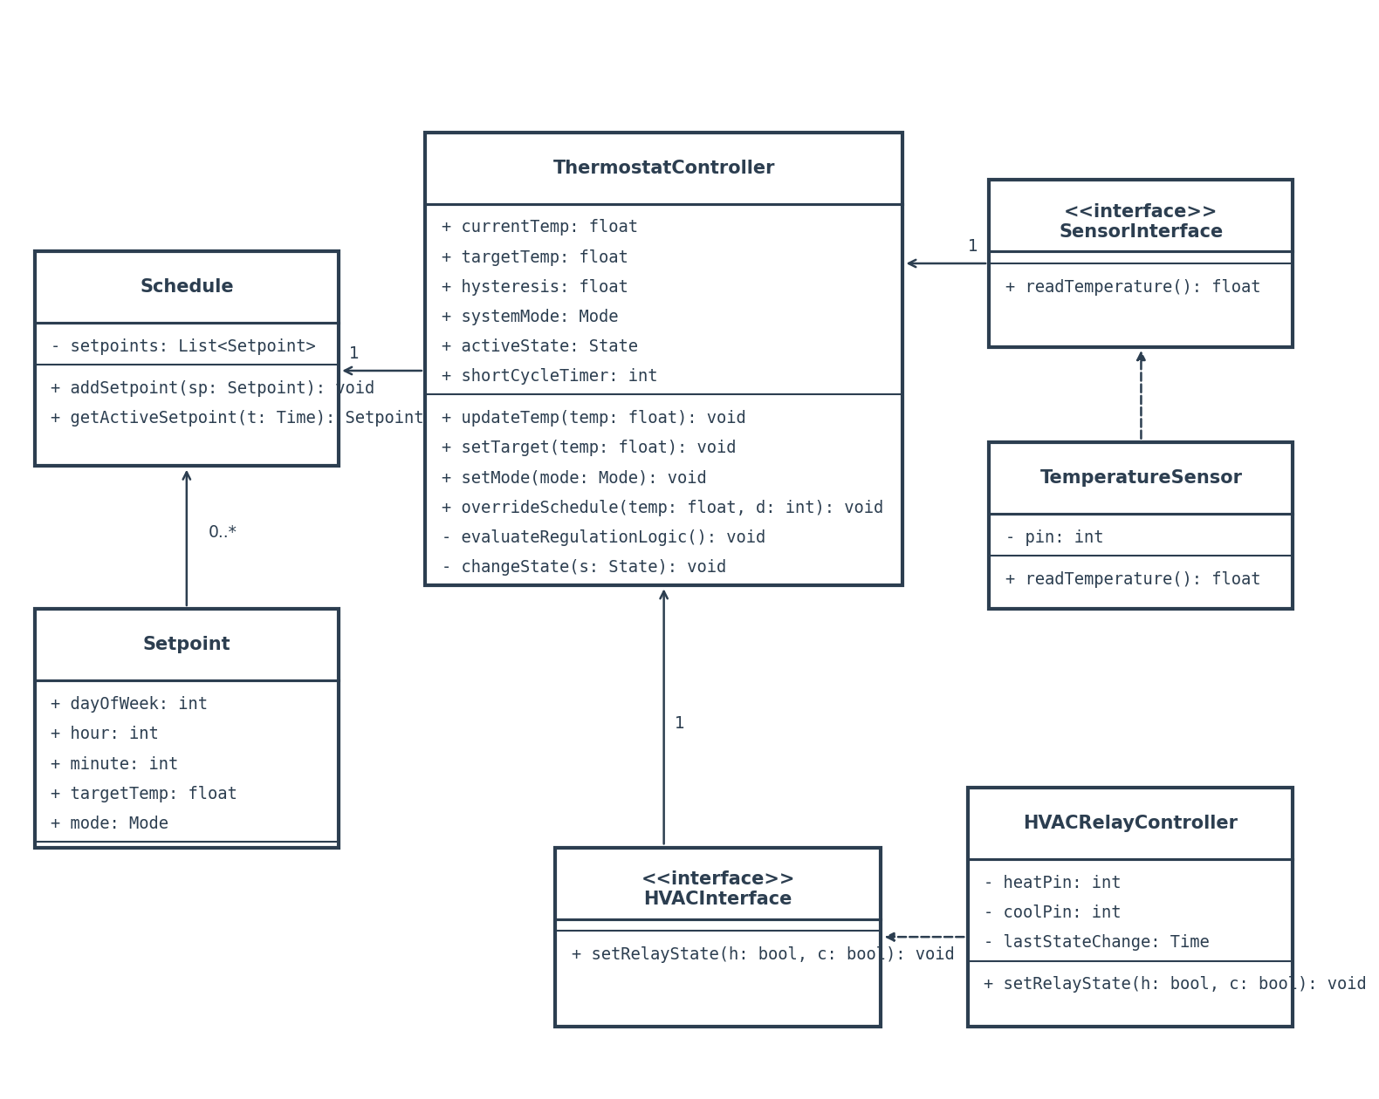
The system shall interface with a local SQLite database to persist schedule configurations and system state logs.

The system shall query the following data from the database:
- Active schedule profile
- User credentials (hashed)
- System configuration parameters (hysteresis, safety limits)
The database shall store operational logs including sensor history, relay state changes, and user override actions. Data access will be abstracted through a Repository pattern.
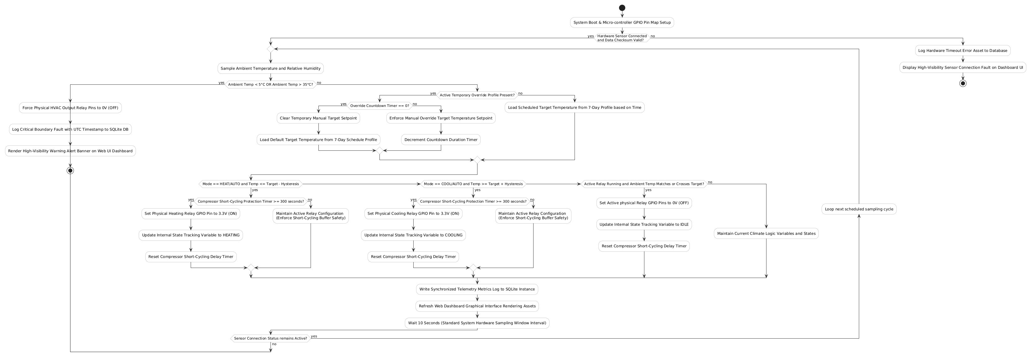

5. System Features/Modules
This section organizes the functional requirements for the product by system features, representing the major services provided by the controller.

5.1. HVAC Regulation Logic

5.1.1 Description and Priority
This feature regulates ambient temperature based on comparing the current sensor reading with the active target setpoint and hysteresis. Priority: High.

5.1.2 Stimulus/Response Sequences
Condition: Ambient temperature drops below (target - hysteresis) in Heat mode.
Response: The system activates the heating relay, provided the compressor safety delay has elapsed.
Condition: Ambient temperature rises above (target + hysteresis) in Cool mode.
Response: The system activates the cooling relay, provided the compressor safety delay has elapsed.

Condition: Ambient temperature reaches target temperature in Heat/Cool mode.
Response: The system deactivates the active relay and returns to Idle state.

5.1.3 Functional Requirements
- REQ-1.1: Upon receiving a temperature reading below (target - hysteresis) in Heat mode, the system shall activate the heating relay if the 5-minute safety delay has elapsed.
- REQ-1.2: Upon receiving a temperature reading above (target + hysteresis) in Cool mode, the system shall activate the cooling relay if the 5-minute safety delay has elapsed.
- REQ-1.3: Upon reaching the target temperature, the system shall deactivate the active relay and enter the Idle state.
- REQ-1.4: Upon sensor disconnection or error, the system shall immediately deactivate all relays and display a system error alert.

5.2 Target Temperature Override

5.2.1 Description and Priority
This feature allows authenticated users to temporarily override the target temperature of the active schedule for a set duration. Priority: Medium.

5.2.2 Stimulus/Response Sequences
Condition: User requests target temperature override through web dashboard.
Response: The system prompts for credentials and, upon validation, displays the override input screen.
Condition: User submits override temperature and duration.
Response: The system validates inputs, updates active target temperature, and starts the override countdown timer.

5.2.3 Functional Requirements
- REQ-2.1: Upon receiving an override request, the system shall verify the user's authentication status before granting access to settings.
- REQ-2.2: If authenticated, the system shall accept override temperatures between 5°C and 35°C.
- REQ-2.3: If the requested override temperature is outside the safety range, the system shall reject the request and display a boundary error message.
- REQ-2.4: Upon successful validation, the system shall apply the override target temperature and start a countdown timer for the specified duration.
- REQ-2.5: Upon override timer expiration, the system shall discard the override settings and restore the scheduled target temperature.
- REQ-2.6: Upon user cancellation, the system shall immediately terminate the override timer and return to the default schedule.

6. Nonfunctional Requirements

6.1. Performance
NF-1.1: The system shall process temperature sensor readings and evaluate regulation logic within 1 second of sampling.
NF-1.2: The web dashboard shall load and display updated room telemetry within 2 seconds under normal network conditions.

6.2. Security
NF-2.1: All communications between the web dashboard and the thermostat controller shall use secure HTTPS
NF-2.2: The system shall hash user plain text passwords using the bcrypt algorithm with a minimum work cost factor of 12 before writing to the database.
NF-2.3: The system shall hash active session tokens using the SHA-256 algorithm before writing to the database.

6.3. Usability
NF-3.1: A first-time user shall be able to set a target temperature override within 30 seconds of logging in.

